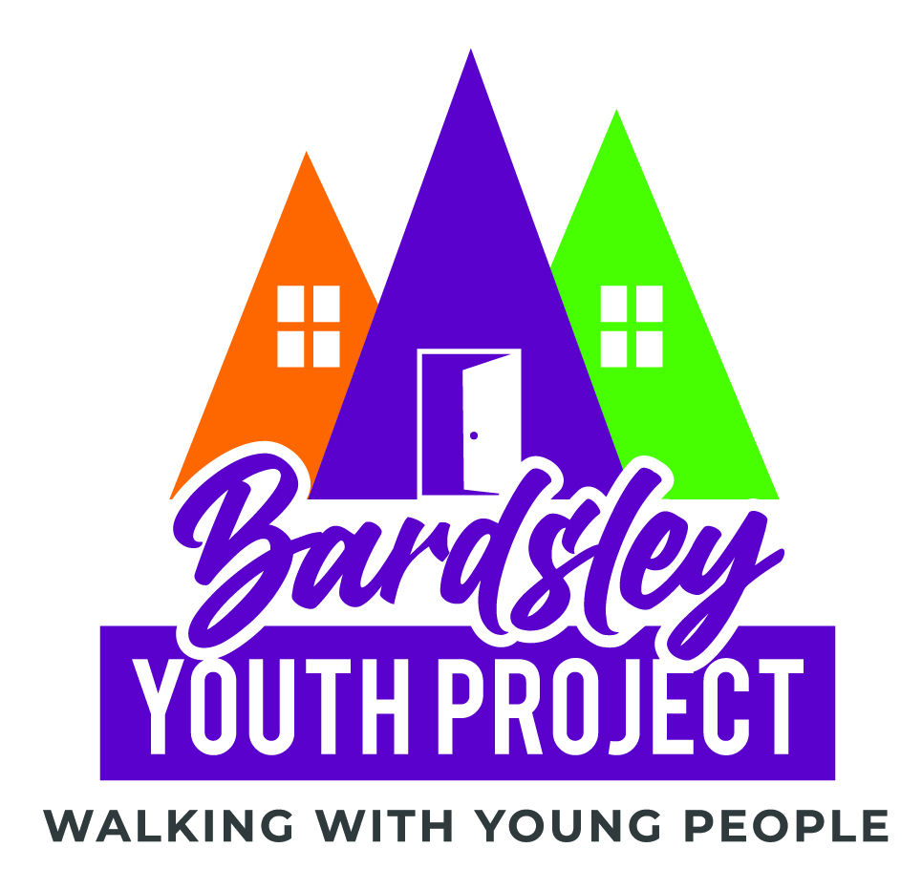

Bardsley Youth Project
Volunteer Application form

Thank you very much for your interest in volunteering for the Bardsley youth Project. Once complete or if would like assistance with completing this form, please contact our manager Simon on simon@bardsleyyouth.org or Call him on 07939 162 717

All the information you provide on this form is confidential and will not be passed on to a third party. B.Y.P complies fully with Current Data Protection and Freedom of Information legislation.

Which roles with BYP are you interest in volunteering for?
Befriending service |  | Donation collection & sorting
Furniture project |  | Open Door day

Full Name; ____________________________________________________________

Date of Birth; __________________________________________________________

Address; ______________________________________________________________

_____________________________________________________ Postcode; _______

Telephone; ______________________
E-mail; _________________________

Emergency Contact

Name; _________________________
Number; _______________

Relationship to you; _______________________

Do you have any medical conditions, disabilities or anything you struggle with we should know about?
Please include information on any support you would like or need form us.

Please tell us why you would like to volunteer for Bardsley youth Project (you can tick more than one box)
I want to help end homelessness |  | I’m interested in meeting new people
To make myself more employable |  | Sharing my skills and experience to help others
Give something back in my community |  | I want to develop new skills
To keep myself busy |  | Something enjoyable to do with my time
I was asked by a friend |  | I want to make a difference
To help me in my journey |  | I believe in this cause
I’ve been homeless and want to give back |  | I’d rather volunteer than give money
To help Young people improve their lives |  | Bardsley Youth Projected helped me
Other, please right in space below

Please tell us a little more about you and what skills and qualities you feel make you suitable for this volunteer role and any relevant experience you may have.

What days and times would you be able to offer?
 | Mon | Tue | Wed | Thu | Fri | Sat
Morning
9am – 12
Lunch
11 – 2pm
Afternoon
1 – 5pm
Evening
5 – 7pm
Please note: All volunteers should have an understanding of and empathise with the Christian ethos of Bardsley Youth Project and fully support the Project’s vision. It is not essential, that volunteers are Christian.

Please give the name, address and contact details of two references.

Name; _________________________

Address; ________________________

_______________________________

Telephone; ______________________

Email; __________________________

Name; _________________________

Address; ________________________

_______________________________

Telephone; ______________________

Email; ________________________

All volunteers are required to complete a DBS (CRB) form applying for Enhanced Disclosure and are required to complete the paperwork without delay.

Here at Bardsley House, we believe that a volunteer should…
- Be flexible and share tasks fairly on request
- Work conscientiously and in line with current working practices of the Project
- Work within all BYPs policies and raise any concerns with their line manager/ BYP manager
- Respect confidentiality
- Accept support and feedback
- Take concerns or problems about volunteer duties to the line/ BYP manager
- Accept direction from the line manager or staff member in charge of the session/activity
- Supply up-to-date contact details and respond to messages within a reasonable time
- Work within the Bardsley Youth Project Safeguarding policy and be willing to undergo Safeguarding training
- Take part in face-to-face debriefing with the line manager after all interactions with young people.

Things you can expect from Bardsley Youth Project.
- A relaxed and enjoyable working environment.
- Any and all training required to do your role.
- An offer of regular 1:2:1s with your line manager.
- Reimbursement for any expenditure subject to prior approval by your line manager / BYP manager, in line with Bardsley Youth Project financial policy.
- Support moving into paid work and progressing in your chosen career if desired.

