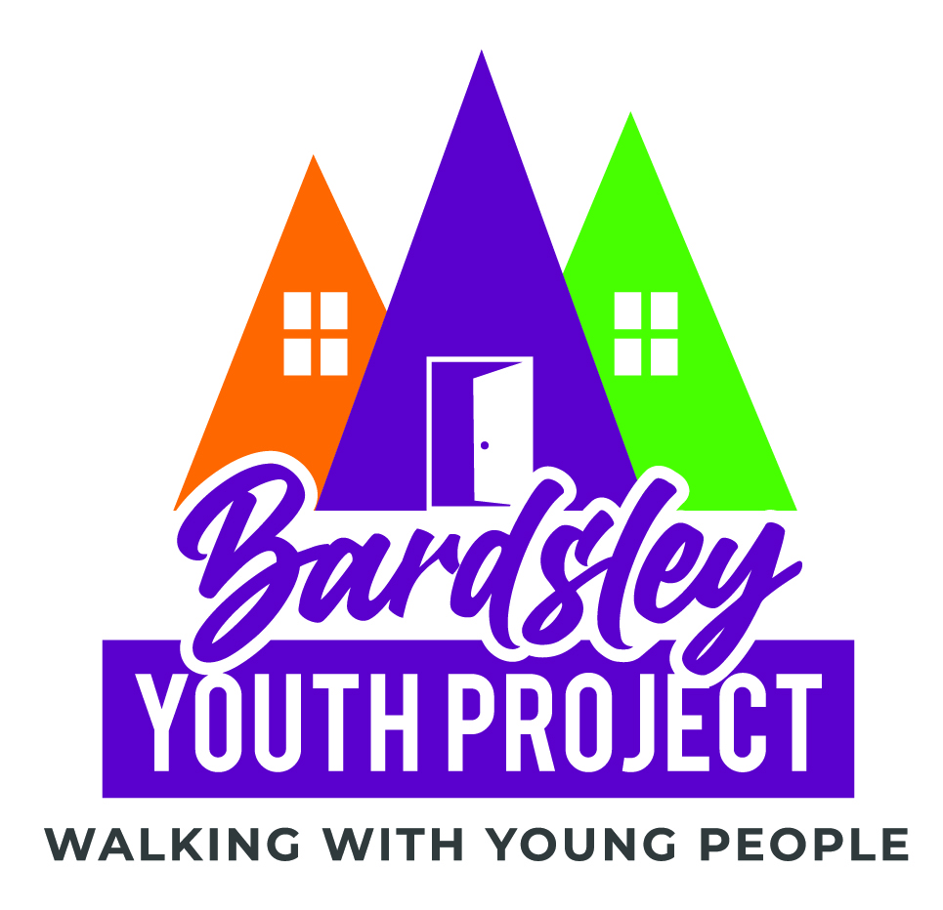Please return completed Forms to [Kim@bardsleyyouth.org](mailto:Kim@bardsleyyouth.org)

**At Bardsley Youth Project we stress the importance of confidentiality but there are limits to our confidentiality. These include if any person is put in a life-threatening situation, if any person shares knowledge of mental, physical or sexual abuse of a person under the age of 18 years or in circumstances where there is a legal obligation for staff and volunteers to act. In these cases, we will act under the relevant policies.**

**I HAVE READ AND UNDERSTAND THIS: _______________________________ (YP)**

**WITNESSED BY: ___________________________________________(Bardsley worker)**

**Date: ______________________**

|  |  |  |  |
| --- | --- | --- | --- |
| Referral Agency: |  | Date: |  |
| Name of Referrer: |  | Contact No: |  |
| Referrer Email Address: |  | | |
| Name of Y P: |  | | | |
| Date of Birth: |  | Age: | | |
| NI Number: |  | | | |
| Contact Details:  (Phone & email) |  | | | |
| Emergency contact:  Name, number, relationship |  | | | |
| **We will need to contact and talk to other agencies and people to help you. We may need to refer you to other people for help as well. Please sign below to agree to this.**  **Signed by young person……………………………………………………………………………………………**  **Signed by Bardsley Staff……………………………………………………………………………………………**  **Date………………………………………………………………………………………………………………………….** | | | | |

**Are there any agencies or people YOU DO NOT WANT US TO CONTACT?**

|  |
| --- |
|  |
|  |
|  |

|  |  |  |  |
| --- | --- | --- | --- |
| Gender: |  | Sexuality: |  |
| Nationality: |  | Ethnicity: |  |
| Legal status: |  | Religion: |  |
| Identification: |  | First language: |  |
| Marital Status: |  | Children/dependants |  |

Address homeless from and whom YP lived with:

|  |
| --- |
|  |
|  |
|  |

Where did YP sleep last night? (Address or location, who stayed with)

|  |
| --- |
|  |
|  |
|  |

Why is YP homeless? Or at Risk of becoming Homeless? (family history, relationships, who they lived with, cause of any relationship breakdown, has YP been homeless before?)

|  |
| --- |
|  |
|  |
|  |

Is YP in training/education/employment? (location, hours, job type, course, payment dates)

|  |
| --- |
|  |
|  |

Is YP in receipt of benefits? (Type, payment dates, signing day) If not, has YP got ID required to apply?

|  |
| --- |
|  |
|  |
|  |

Is YP a care leaver? (who is their social worker, details of time spent in care and at what age)

|  |
| --- |
|  |
|  |

Are there any other agencies/organisations working with YP? (contact details of contact person)

|  |
| --- |
|  |
|  |

Any steps already taken by YP to get accommodation? (Organisations/agencies who they have approached — have they been to Council Customer Services?)

|  |
| --- |
|  |
|  |
|  |
|  |

Does YP have rent arrears or are they excluded from certain places of accommodation?

|  |
| --- |
|  |
|  |

|  |  |
| --- | --- |
| GP information: |  |
| Dentist Information: |  |

Medical History, to include physical and mental health issues

|  |
| --- |
|  |
|  |
|  |

Convictions/Pending Investigations

|  |
| --- |
|  |
|  |

Areas Of Concern (Drug/alcohol addictions, Gambling, incidents of violence, learning difficulties)

|  |
| --- |
|  |
|  |
|  |
|  |
|  |
|  |
|  |
|  |
|  |
|  |